Title: **Fleming's Right Hand Rule** Worksheet: 21

Course: Electrical Applications Unit: Electrical Theory CLO: 3

Name ANSWER KEY Grade 6pts. Date ______________

**Objectives**

1. Student shall determine the current induced in a conductor when moved through a magnetic field.
2. Student shall apply Fleming’s Right-Hand Rule to determine the direction of *conventional current* flow.

**Assessment**

Students shall demonstrate a comprehension of the objectives listed above by scoring a minimum of 75% on this Worksheet. Grading shall be based on an answer key.

**Theory**

Fleming’s Right Hand Rule is used to determine the direction of *conventional current* that is induced in a conductor when brought in the presence of a magnetic field. If you place the thumb, first finger and second finger of your right hand in mutually perpendicular position, you may apply Fleming’s Right Hand Rule. The thumb shall point in the direction that the conductor will move. The first finger shall point in the direction of the magnetic *lines of force*. The second finger shall point in the direction that the induced *conventional current* will flow.

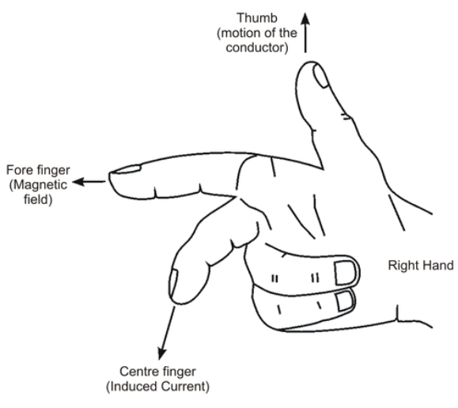

An easy way to remember the purpose of each finger in Flemming’s Right Hand Rule is as follows;

* Thu***m***b – the “m” in thumb stands for *movement* or *motion*.
* ***F***irst – the “F” in first stands for the *field* (magnetic field lines moving N to S).
* Se***c***ond – The “c” in second stands for the *conventional current* direction.



The cross-section of the conductor, the circle shown above, has either a plus “+” or a minus “-” sign. This indicates the direction of *conventional current* flow. A plus sign will indicate that current is coming out of the conductor. A minus sign indicates that current is going into the conductor.

**Instructions**

Determine the direction of induced conventional current in the conductor. Draw either a plus (+) sign or a minus (-) sign inside the conductor to determine the direction of conventional current flow. A plus sign indicates that the current would be exciting the paper while a minus sign indicates that the current would be entering the paper.





**Instructions**

Determine the poles of each magnet given the direction of the current the magnetic *lines of force* direction.



S

N

S

N

